Hardee County Citizens

Hardee County Board of County Commissioners

County Attorney,

# Sarah Johnston

County Manager,

# Terry Atchley

Assistant County Manager, **Douglas Baber**

Assistant County Manager, **Christoper Simpron**

Public Works Director, **Rick Taylor**

General Services Director**,**

# Lorie Ayers

Admin Services Manager, **Holly Smith**

Public Safety Director, **Casey Dasher**

Community Development Director, **Todd Miller**

Marketing & Tourism Manager,

# Lacey Webb

Human Resources & Risk Management

Capital Projects

Fleet Management

Office of Management & Budget

Mining

Emergency Management

Building

Solid Waste

Parks & Recreation Infrastructure

Facilities Management

Grants Management

Soil & Conservation

Fire / EMS

Code Enforcement

Utilities

Tourism

Road & Bridge

Procurement

Veterans Affairs

Probation

Planning & Zoning

Library

Extension Office

Information Technology / GIS

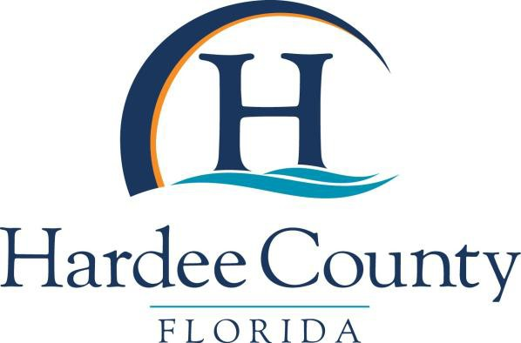

Effective 11/19/2024